 | Assignment No. 02  SEMESTER Spring 2021(Solution)  CS403- Database Management System | Total Marks: 20  Due Date: 7th June, 2021
Instructions
Please read the following instructions carefully before solving & submitting assignment:
It should be clear that your assignment will not get any credit if:
- The assignment is submitted after due date.
- The submitted assignment does not open or file corrupt.
- The assignment is full or partially copied from (other student or ditto copy from handouts or internet).
- Student ID is not mentioned in the assignment File or name of file is other than student ID.
- The assignment is not submitted in .doc or .docx format.

Uploading instructions
Your submission must include:

- Assignment should be in .doc or .docx format.
- Save your assignment with your ID (e.g. bx020200786.doc).
- Assignment submission through email is NOT acceptable.

Objectives
The objective of this assignment is
- To be able to understand Entity Relationship diagrams.
- Relationship Cardinalities
Note:
Your answer must follow the below given specifications.
- Font style: “Times New Roman”
- Font color: “Black”
- Font size: “12”
- Bold for heading only.
- Font in Italic is not allowed at all.
- No formatting or bullets are allowed to use.
- Your answer should be precise and to the point, avoid irrelevant detail.

Deadline
Your assignment must be uploaded/submitted at or before 7th June, 2021.

Question Statement:
Our second assignment is the continuation of our first assignment.
In the first assignment you were required to draw the context level diagram and the level 0 DFD which are given below.
Context level diagram:
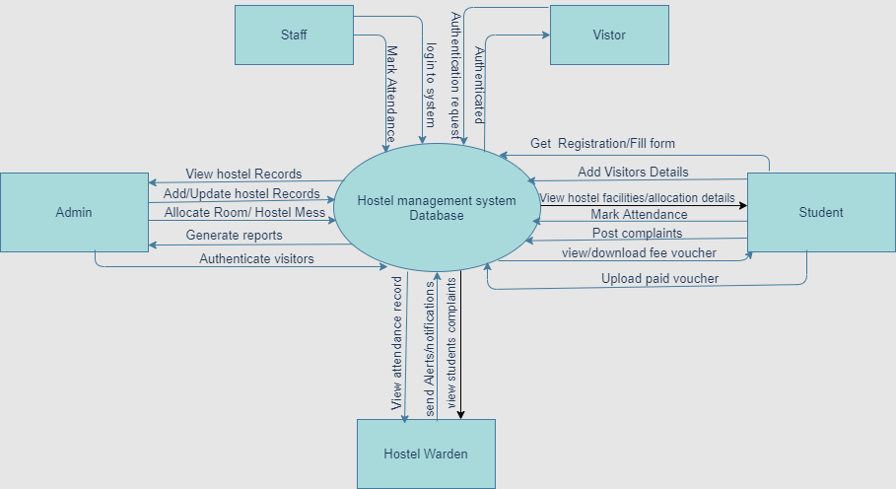

Level 0 DFD:
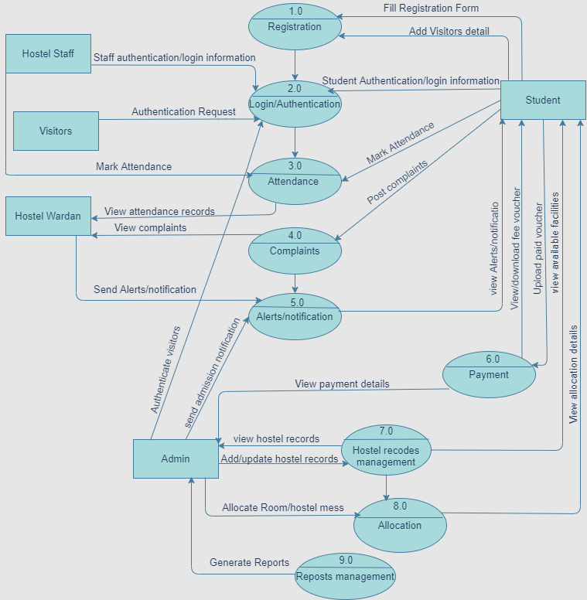
Scenario:
A hostel is like a 2nd home for the students who are living outside the home. The purpose of development of hostel management system (HMS) is to manage hostel activities and to maintain all records which are difficult to manage and maintain manually. By using a computerized system, it is easy to keep the record of students, rooms, visitors, hostel staff and attendance. All this data will be stored in hostel management system database.
After getting admission in a college/university, if a student is not a local student then he/she can apply for hostel residence. At the time of registration, an admission form is filled by students. While filling a form, students need to provide visitors detail so that only registered visitors can visit a student after getting authentication by hostel admin. Admin can allocate room and hostel mess to a student. After getting admission confirmation notification from hostel authorization, a student can view available facilities and hostel allocation details. Hostel admin is responsible to provide basic facilities like library, newspaper, electricity, internet and meal facilities to all the students. In a student’s fee voucher, calculation of hostel mess charges depends on student’s presence/stay and utilization of this facility. Students can view and download hostel fee voucher, after paying fee students should upload paid fee voucher. Students can post complaints and view notification/alerts generated by hostel warden.
Hostel staff (hostel warden, employees, mess staff etc) can login to mark attendance. Hostel warden should be able to view students and staff’s attendance records, view student’s complaints and can send alerts or notifications to students. Hostel admin can view hostel records (students, staff, rooms, visitors, attendance, payment etc details). He/she can add/update hostel records (students, staff, rooms, visitors, attendance, payment etc details). Admin should also be able to generate students, staff and dues reports.

You’re required to perform the following tasks according to above scenario.

- Draw the Entity Relationship diagram.
- Draw relationship cardinalities in alphabetical notation.

Solution:

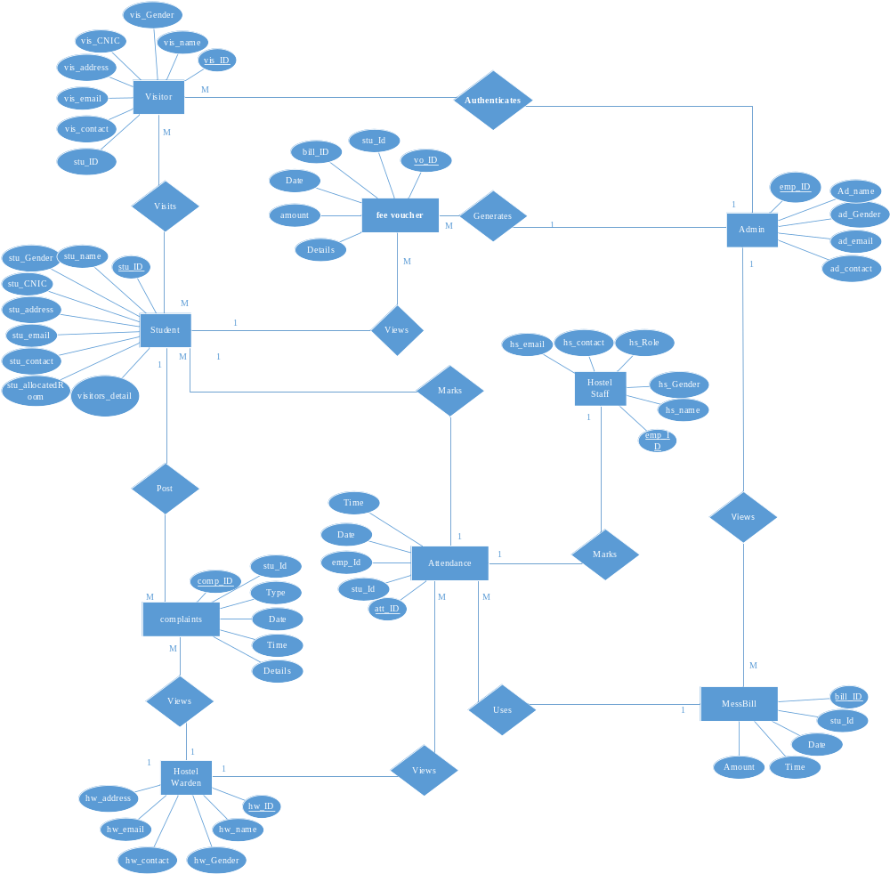
=====================================Ended=======================================

For any query about the assignment, contact at CS403@vu.edu.pk

GOOD LUCK

